Grade 12 IT

Data Validation Task - 2018

Create a GUI with components (radio buttons, combo boxes, check boxes etc.), where data validation is done using exception handing and programming code with detailed error messages.

1. Create a GUI to accept as input the following four data types
   1. Numeric (e.g. What is your height or how many siblings do you have)
   2. Boolean (e.g. are you male or female)
   3. String (e.g. What is your first name, an Identity number)
   4. Date/Calendar (choose an appropriate date using the date picker) using the most appropriate component for each data type.
2. Select the most appropriate GUI components to eliminate incorrect input and provide the first level of data validation. (Note that the Date type can be validated using methods from existing classes such as the JDatePicker in Java.)
3. Make sure you use good GUI design techniques:
   1. Labels, buttons, tables, fields all correctly named according to conventions.
   2. Clear layout, with consistent fonts, colours, size of fonts, and buttons.
   3. Fields are aligned and clearly labelled
4. Provide a further level of validation using programming code (and possibly exception handling) to perform any **FOUR** of the following validation checks on one or more field. (Note that some fields may not require further validation checks, and can be sufficiently validated using the appropriate GUI component.)

|  |  |  |
| --- | --- | --- |
| **Validation Type** | **How it Works** | **Example Usage** |
| Check Digit | The last one or two digits in a code  are used to check the other digits are correct | Bar codes, ISBN numbers, credit card  numbers |
| Format Check | Check the data is in the right format | A number plate being ABC 999 GP |
| Length Check | Checks that the data is not too long  or too short | A password is ten characters long |
| Lookup Table | Looks up the acceptable values in a  table | There are only seven possible days in the  week |
| Presence Check | Checks that data has been entered  into a field | An ID number cannot be blank |
| Range Check | Checks that a value falls within the  specified range | The number of hours worked can be  between 0 and 50 |
| Type Check | The data entered is the correct type | The value for a height is a real number. |
| Logic Check | The value entered is logically correct | A person in Grade 12 cannot have an age  less than 16 or greater than 19. |

# Example using one field (the four validation rules can apply to more than one field):

STRING: Identity Number

* Format Check – All digits present, the first 6 are a valid date
* Length Check – 13 digits
* Presence Check – available or not
* Check Digit – last digit is correct

# Possible GUI Design

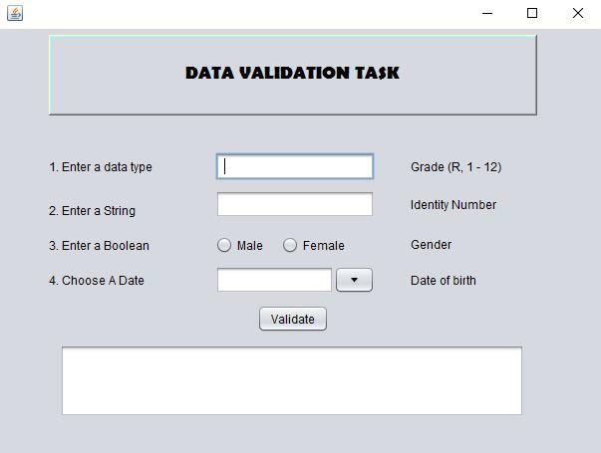

1. The program must include a detailed error message for each and every error. Incorrect values must be indicated by highlighting the field’s component and describing the error in an adjacent label. If all fields are acceptable, then a label must display an appropriate message.
2. Submit a Data Validation document as evidence of your task. Your document must consist of the following:
   1. Title page including the candidate’s name, examination number, centre details and title of the task, table of contents and page numbers
   2. An image of GUI before data is entered.
   3. A table included in Appendix A.1 that describes each field to be input, the type of GUI chosen for this field, the reason for the choice of GUI component and type of data validation that is performed using programming code.
   4. A test plan for each validation rule using standard, extreme and abnormal data.
   5. Evidence of testing using before and after screen shots.
   6. A copy of all programming code.

**TOTAL: 50**